
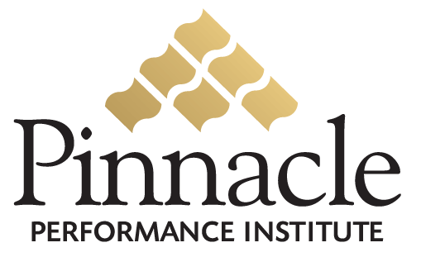
Performance Enhancement Solution
Application

CUSTOMER INFORMATION

Contact Name
David Call
Company Name
Team Everest
E-mail Address |  |  |  |  |  |  |  |  | Telephone #1
Mailing Address |  | City / State |  |  |  |  | Zip Code |  | Telephone #2
Website |  |  |  |  | Preferred Logon Name |  |  |  | Preferred Password
www.TeamEverest.biz
Account Executive Name (Last, First, Middle Initial) |  |  |  |  | Account Executive ID Number |  |  |  | Account Executive’s Telephone
Bob Wood |  |  |  |  | --- |  |  |  | ---

PAYMENT INFORMATION
X | Bill Customer For All Memberships

Price per Membership Terms
1 – 1,000 $20.00 Balance Due 15th of the month
1,001 – 3,000 $19.00 2% Late Fee after 15th
3,001 – 10,000 $18.00 System Termination after 30 days late
10,001 – 25,000 $17.00
25,001+ $16.00

I understand that Pinnacle agrees to:
- Provide the Customer with a private-labeled Pinnacle Performance Enhancement Solution to train and monitor its members, employees and/or independent agents.
- Provide the Customer with a secured Internet back-office to customize and maintain its Pinnacle Solution.
- Provide the Customer’s members with secured Internet access to receive the training courses and related services.
- Maintain an independent relationship with the Customer and prevent any suggestion of endorsement by the Customer.
- Maintain confidentiality of all customer and member personal and financial information. Such identified confidential information will only be used to fulfill the Pinnacle Solution service.
- Recognize full rights and ownership of the original content by the Customer while maintaining ownership of its digital conversion.
- Reserve the right to approve or disapprove any and all training content according to the appropriateness for its members at the complete discretion of Pinnacle.

I agree to:
- Provide a Program Manager for all setup needs and ongoing system and member maintenance.
- Provide the required certifications and necessary training and development courses for the members.
- Provide regular major promotions for the member usage of the solution.
- Ensure that only one individual and their immediate family members utilize each membership account.
- Maintain an independent relationship with Pinnacle and prevent any suggestion of endorsement by Pinnacle.
- Maintain full and complete ownership of the original intellectual property content granting the nonexclusive right to Pinnacle to edit and convert the original content into a digital format appropriate to the needs of Pinnacle.
- Warrant that I have complete legal rights and authority to provide the training content and is not infringing any copyright or other such laws.
- Issue written notification to Pinnacle of my termination of this agreement effective within thirty days of notice.

My signature indicates that I have read and accept all the terms and conditions regarding privileges and obligations of the Pinnacle Performance Enhancement Solution as outlined on this application.

Printed Name Title

Signature Date

Send signed application to 400 Chisholm Place, #411, Plano, TX 75075, (775) 252-8187 fax Copyright 2005 Pinnacle Performance Institute 3/19/05

